**Triggers**

A trigger refers to an Apex code that is automatically executed before or after certain events occur in the Salesforce platform, such as when a record is inserted, updated, deleted, or undeleted. Triggers are used to automate business processes, enforce data integrity, and perform custom logic on data.

A before trigger in Salesforce is executed before the records are actually inserted, updated, or deleted in the Salesforce database. This allows the trigger to perform certain actions or validations before the data is saved to the database.

* Write A Trigger

write a trigger whenever the school website is null you should be unable to delete the record.

Go to the gear icon and select the developer console.

From the menu bar click on file and select Apex class.

Now give the class name as schoolHandler

Now Write the below code

public class schoolHandler {

public static void beforeDelete(list<School__c> oldlist){

for(School__c s : oldlist){

if(s.Schoolwebsite__c == null ){

s.addError('you cannot delete the record');

}

}

}

}

From the menu bar click on file and select Apex trigger.

Now give the trigger name as Internalmarks

Now write the below code

trigger SchoolTrigger on School__c (before delete) {

if(trigger.isDelete){

if(trigger.isBefore){

schoolHandler.beforeDelete(trigger.old);

}

}

}

**Flows**

Record-triggered flows are a powerful automation tool in Salesforce that can streamline business processes,reduce manual work, and improve productivity. They can be used to automate a wide range of tasks, from simple to complex, and can be tailored to meet the unique needs of your organization.

Create Flow

Create a record triggered flow whenever a student record is created it must send the email to the student about their welcome.

Click on Gear icon and select setup

In Quick find Box enter flow and select the flows

Click on New flow and Select Record triggered Flows. 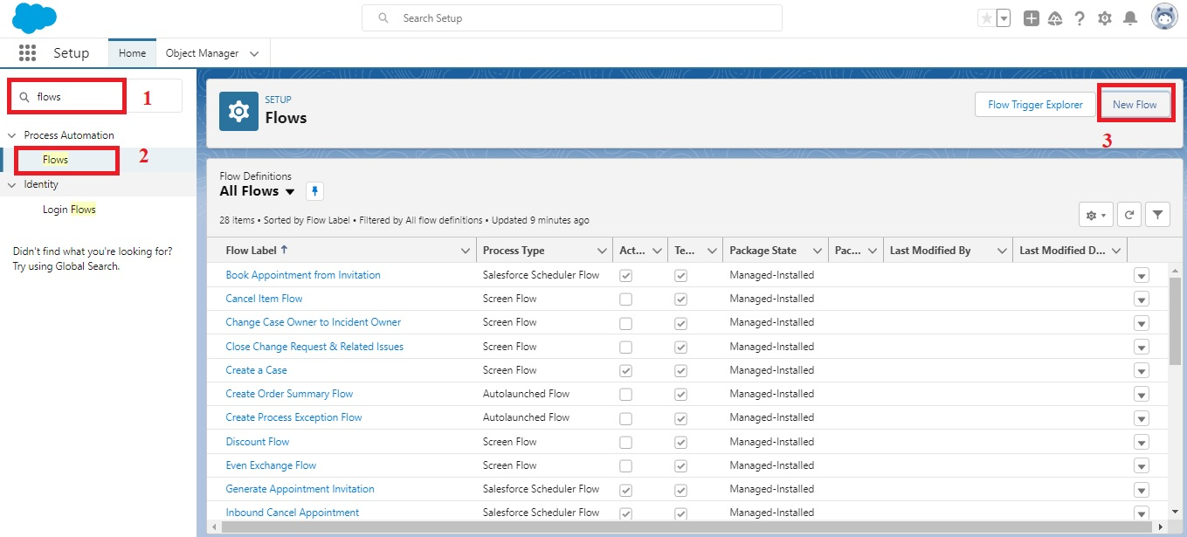

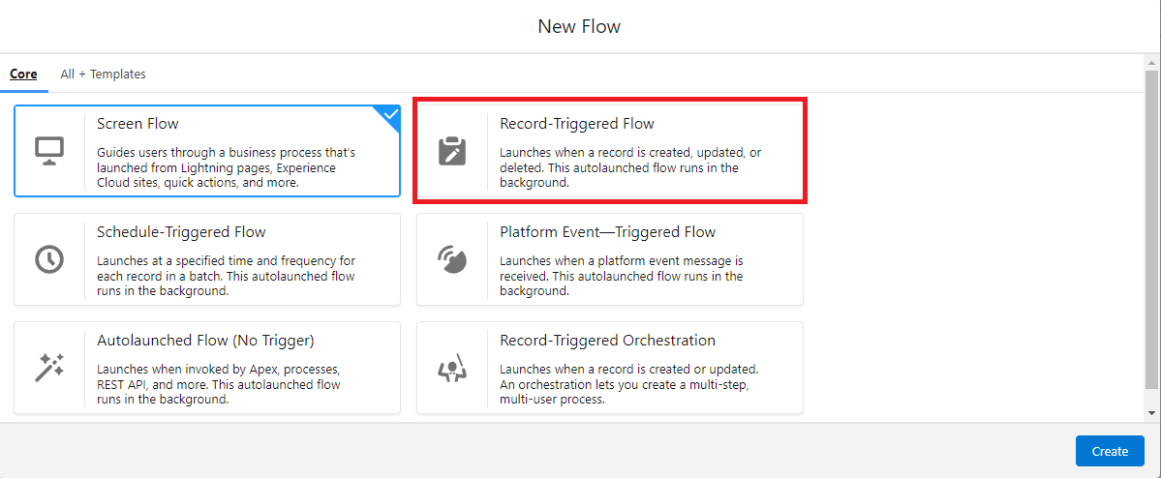

In the search bar type student and click done.

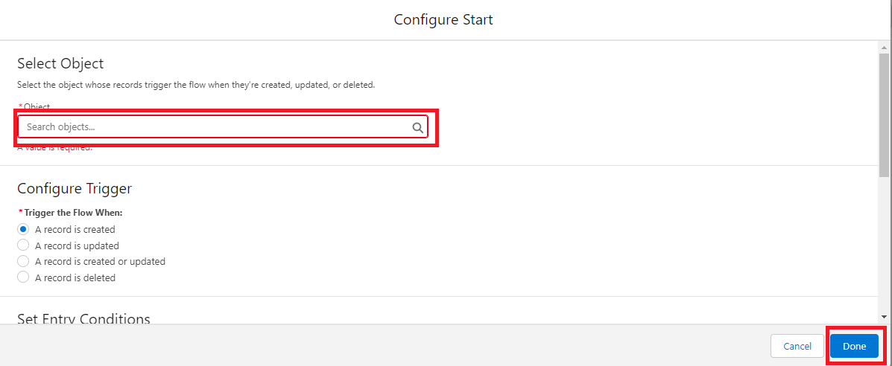

Select (+)

type action and type email as follows.

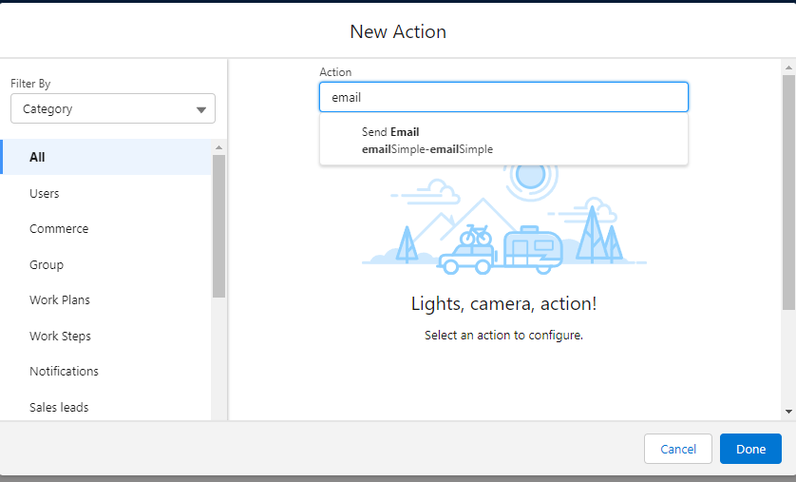

Enter the following details

Label:Student Record Creation

Api Name:Student_Record_Creation( Auto-pupulated)

Body: Hi {!$Record.Name} , we are happy to inform you that you have joined in our {!$Record.school__r.Name}.Subject: Record Creation

Recipient email Address:{!$Record.Email__c}

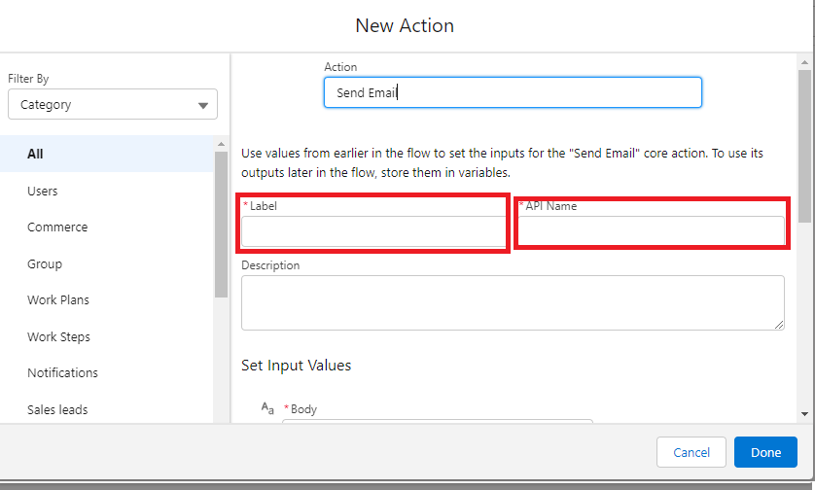

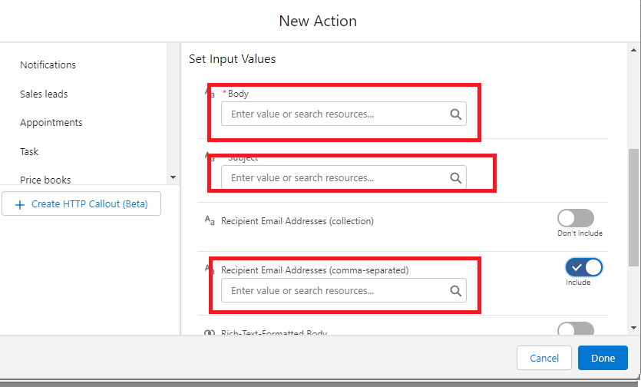

click on done and Click on save

Flow label:Student flow

Flow API Name:Student_flow

and then click Activate.

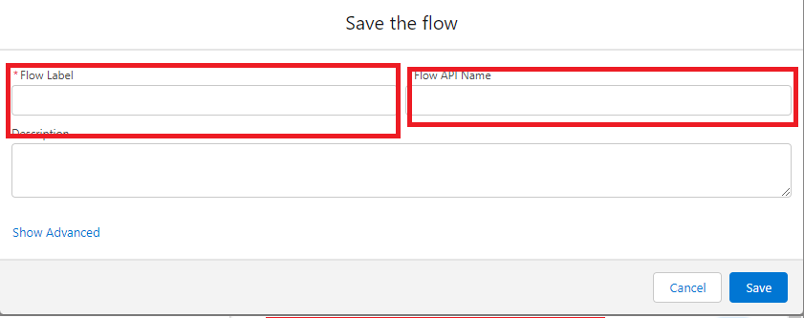

**The end**